

The School Sport Unit Code of Conduct (2025)

Young people involved in Sport have a right to participate in a Safe
and Supportive Environment

Players, Teachers, Coaches and Spectators Code of Conduct
- The goals of the game are to have fun and improve skills
- Be modest in success and generous in defeat
- Play for the fun of it
- Play by the rules and always respect the decisions of officials
- Make no criticism either by word or gesture
- Deliberately distracting or provoking an opponent or player is not acceptable or permitted in any sport
- Be a good sport. Applaud good performance and efforts from all individuals and teams. Congratulate all participants on their performance regardless of the games’ outcome
- Condemn unsporting behaviour and promote respect for opponents
- Condemn the use of violence in any form
- Respect the rights, dignity and worth of all participants regardless of their gender, ability, cultural background or religion
- Ensure any use of social media about or around school sport events, teams and management is responsible and appropriate
- Place the safety and welfare of the participants above all else
- All school sports events are alcohol and smoke free zones

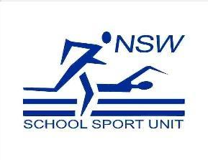 |  | Regards,  David Kinniburgh - Fairvale PS  Lansdowne Zone President
I have read the Code of Conduct and agree to abide by the code as stated above whenever
I am participating in, representing in or attending a Lansdowne Zone PSSA sporting event.

Student Signature: _________________________________

Parent Signature: ___________________________________ Date: _________________

