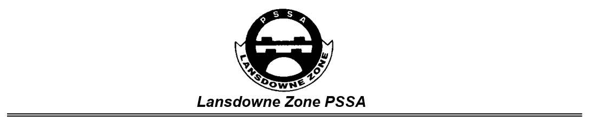
Lansdowne Zone PSSA Code of Conduct (Season 3)
All students and coaches participating in PSSA, have a right to be involved in games that are played within in a safe, friendly and supportive environment.
Student / Participant Code of Conduct
- All games are to be played safely, rules followed, and umpiring decisions accepted. Players should not argue or react in a negative way to decisions made. Only the on-field team captain can approach the referee / umpire to clarify decisions made. It is important to remember that when you play sport, you play for enjoyment: win, lose or draw.
- Swearing at or towards other players, coaches or umpires/referees is not allowed. Words and actions used to upset others, are also not allowed (this is inclusive of racist, rude and insulting language).
- Participants must listen to and follow instructions from all teachers, regardless of the school they are from.
- It is important to be aware that there are consequences for forgetting how to behave in a safe, friendly and supportive way at Primary Schools Sport (PSSA). These consequences may include warnings given during play, time out during a game or not being allowed to play in future games. It is likely that if a game needs to be stopped, the team who has forgotten how to behave, will have a loss recorded regardless of the score.
Parent / Spectator Code of Conduct
- To model positive behaviours, encouraging students and to promote the following of rules of the game.
- To focus on enjoyment, effort and performance, rather than the result of the game.
- To be respectful of decisions made by officials/coaches, whether you agree or disagree with them.
- To listen to and follow directions from all teachers at PSSA events, regardless of the school they are from.
- To ensure that all Primary School Sports (PSSA) events are smoke and alcohol-free environments.
- To be aware that there are consequences for breaching the Parent/Spectator Code of Conduct at PSSA events. These may include warnings being given or the direction to remove oneself from the vicinity of where games are being played. Games may also be stopped and a loss recorded for the offending team, regardless of the score, if parents/spectators refuse to follow directions issued after warnings have been given.
Teacher / Coach / Umpire / Referee Code of Conduct
- To prioritise the safety and welfare of students above all other aspects of the game and to ensure that Duty of Care requirements are always met for all students.
- To develop student potential and to support learning of the game through positive feedback and encouragement.
- To exhibit the behaviours that are expected by students and to always set a positive example for them to follow.
- To be familiar with the rules of the game and to referee/umpire in a manner that is respectful of all students and opposition coaches. Decisions can be questioned in a respectful and appropriate manner, away from students.
- To be responsible for the behaviours of all students and spectators present.
- To address all student/parent/spectator/game official Code of Conduct breaches with your school Principal or Principal delegate and PSSA Coordinator.
Please note that the Lansdowne Zone PSSA Executive and/or School Executive, may impose disciplinary measures on an individual or a team, for breaches to these Codes of Conduct.
Regards, the Lansdowne Zone PSSA Executive
I have read the relevant Code of Conduct above and agree to abide by the Code, as stated, whenever I am participating in or attending Lansdowne Zone PSSA sporting events.
Student Signature: ________________________________________ Date: ______________________

Parent Signature: _________________________________________ Date: ______________________

